浙 江 财 经 大 学

实 验（实训）报 告

项 目 名 称 邹检验（Chow test）
所属课程名称 计量经济学（双语）
项 目 类 型 验证性实验
实验(实训)日期 25年03月 18日

班 级 22应用统计
学 号 220110780419
姓 名 刘晓亮
指导教师 倪伟才

浙江财经大学教务处制

一、实验（实训）概述：
【目的及要求】
目的: 学会用虚拟变量进行项目评价分析；理解Chow 检验的本质，掌握Chow 检验的方法，并体会其局限性；掌握用Stata产生多分类变量的虚拟变量的使用技巧；掌握Stata的bysort和regress相结合使用来估计不同组的回归方程。通过此题体会Stata的优越性。

要求:掌握Chow 检验,按具体的题目要求完成实验报告,并及时上传到彩云系统。
【基本原理】
Chow 检验
【实施环境】（使用的材料、设备、软件）
STATA软件
二、实验（实训）内容：
【项目内容】
Chow 检验
【方案设计】
题目来自 Wooldridge <<Introductory Economerics>> chapter 7 C7.11。熟练使用Stata的操作，如产生多分类变量的虚拟变量，bysort和regress相结合使用来估计不同组的回归方程。不仅掌握用 Chow test检验两组不同的回归方程，而且也要学会检验多组的回归方程。
【实验（实训）过程】（步骤、记录、数据、程序等）
附后
【结论】（结果、分析）
附后
三、指导教师评语及成绩：
评语：分析深入浅出，逻辑清晰

成绩： 优秀 指导教师签名：倪伟才
批阅日期： 25年04月

实验题目：
[abstracted from << Introductory Economerics >>chapter7 C7.11]
Use the data in 401KSUBS. DTA for this exercise.
(i)Compute the average, standard deviation, minimum ,and maximum values of nettfa in the sample.
(ii)Test the hypothesis that average nettfa does not differ by 401(k) eligibility status; use a two-sided alternative .What is the dollar amount of the estimated difference?
[Hint: regress nettfa on e401k]
(iii) Estimate a multiple linear regression model for nettfa that includes income, age, and e401k as explanatory variables. The income and wage variables should appear as quadratics. Now ,what is the estimated dollar effect of 401(k) eligibility.
(iv)To the model estimated in part(iii) ,add the interactions e401k*(age-41) and e401k*(age-41)².Note that the average age in the sample is about 41,so that in the new model ,the coefficient on e401k is the estimated effect of 401(k) eligibility at the average age. Which interaction term is significant?
(v)Comparing the estimates from parts(iii) and (iv) ,do the estimated effects of e401(k ) eligibility at age 41 differ much? Explain.
(vi)Now, drop the interaction terms from the model ,but define five family size dummy variables:fsize1,fsize2,fsize3,fsize4 and fsize5.The variable fsize5 is unity for families with five or more members. Include the family size dummies in the model estimated from part(iii) ;be sure to close a base group .Are the family dummies significant at 1%level?
(vii)Now, do a Chow test for the model
across the five family size categories ,allowing for intercept differences. The restricted
sum of squared residuals, SSRr ,is obtained from part(vi) because that regression assumes all slopes are the same. The unrestricted sum of squared residuals is
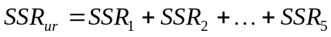,wher SSR_{f} is the sum of squared residuals for equation estimated using only family size f. You should convince yourself that there are 30 parameters in the unrestricted model(five intercepts plus 25 slopes)
and 10 parameters in the unrestricted model(five intercepts plus 5 slopes).
Therefore, the number of restrictions being tested is q=20,and the df for the unrestricted model is 9275-30=9245.

实验题目分析报告：
(i)

pwd
ls
use "401ksubs.dta",clear
// 第一问
desc
sum nettfa, detail
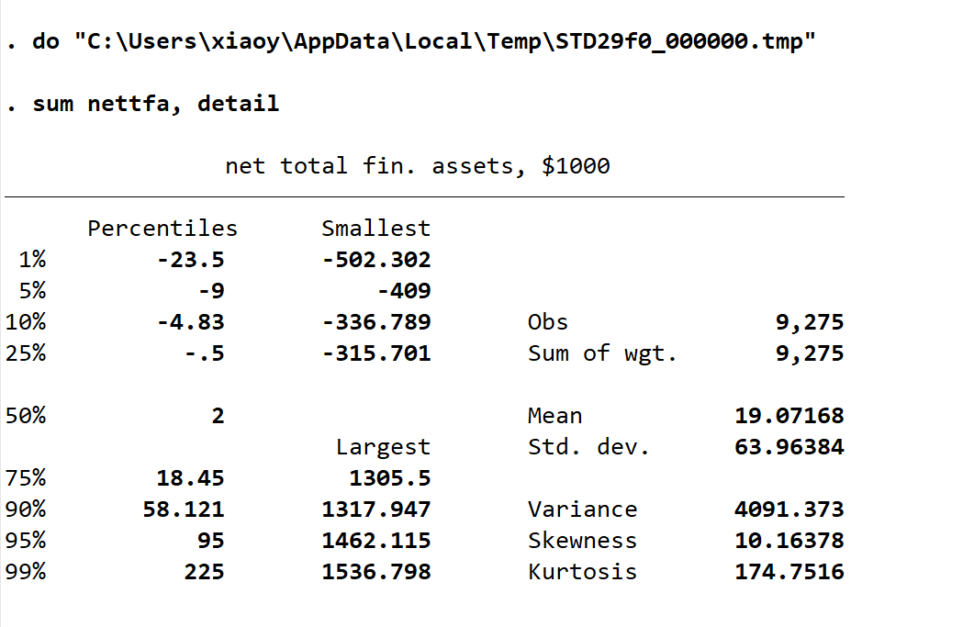
(ii)

reg nettfa e401k
- p值显著，拒绝“平均nettfa无差异”的原假设。
- 结论：401(k)资格家庭比非资格家庭平均多18,858美元的净总金融资产。
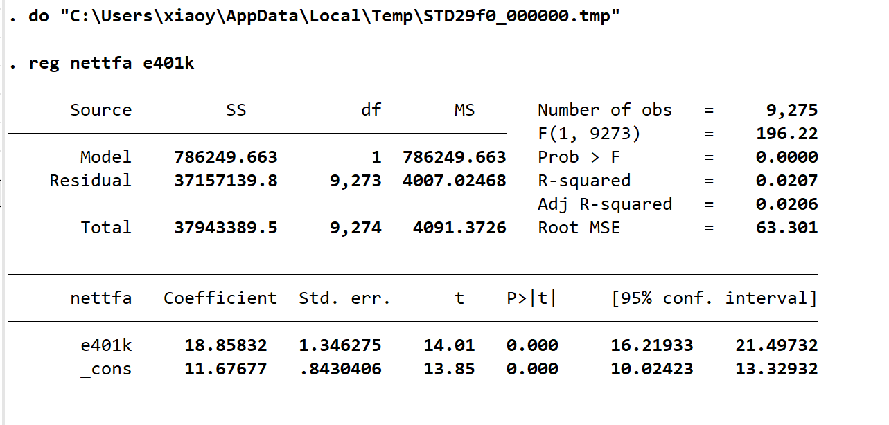
(iii)
reg nettfa inc incsq age agesq e401k
nettfa=23.09+9.705×e401k−0.278×inc+0.0103×incsq+1.972×age+0.0348×agesq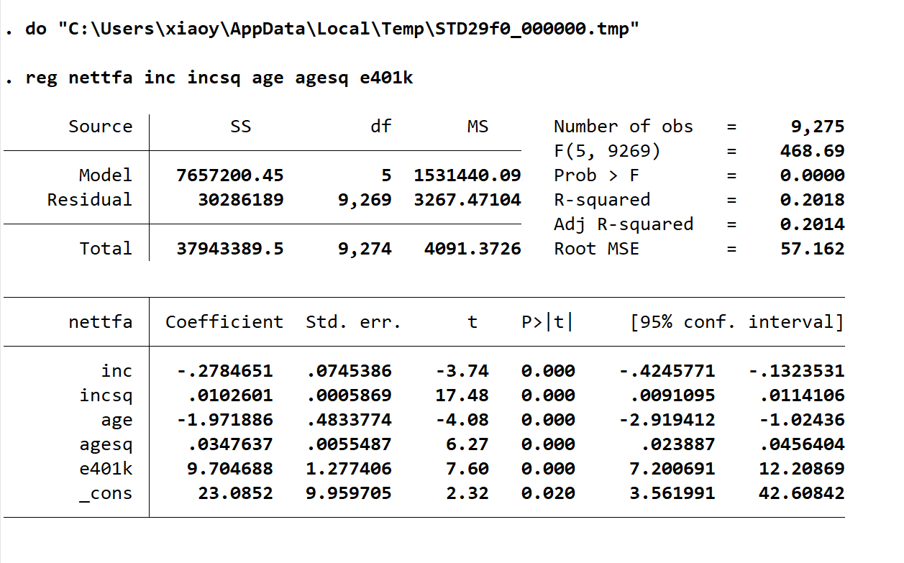
(iv)
gen age_41 = age - 41
gen age_41_2 = age_41^2
gen e401k_age_41 = e401k * age_41
gen e401k_age_41_2 = e401k * age_41_2
reg nettfa inc incsq age agesq e401k e401k_age_41 e401k_age_41_2
- 交互项 e401k_age_41 显著
- 交互项 e401k_age_41_2 不显著
- 结论：401(k)资格对净总金融资产的影响随年龄增加而增强，但二次交互项可以忽略。
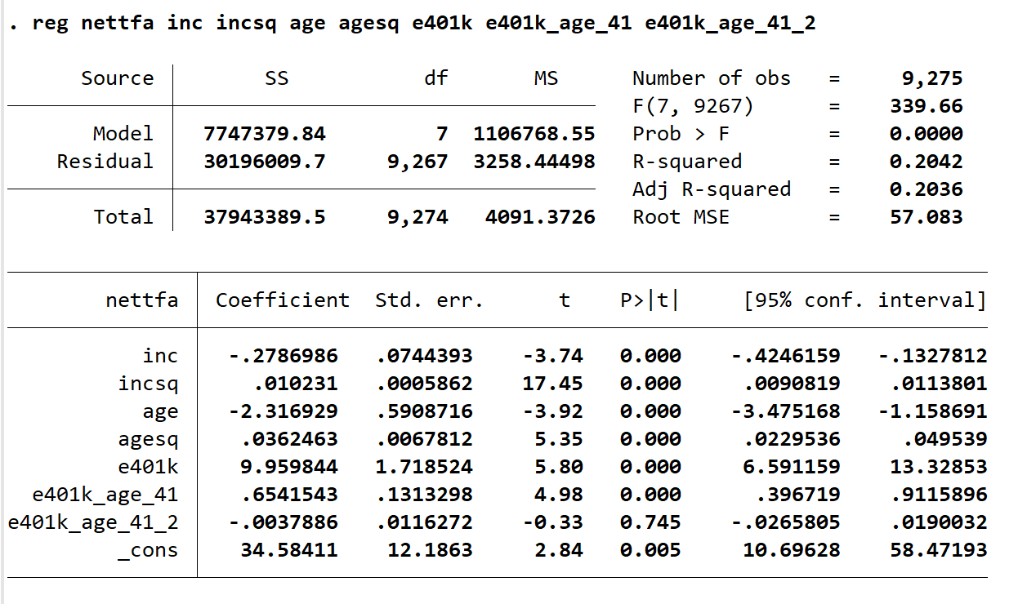
(v)
reg nettfa inc incsq age agesq e401k
reg nettfa inc incsq age agesq e401k e401k_age_41 e401k_age_41_2
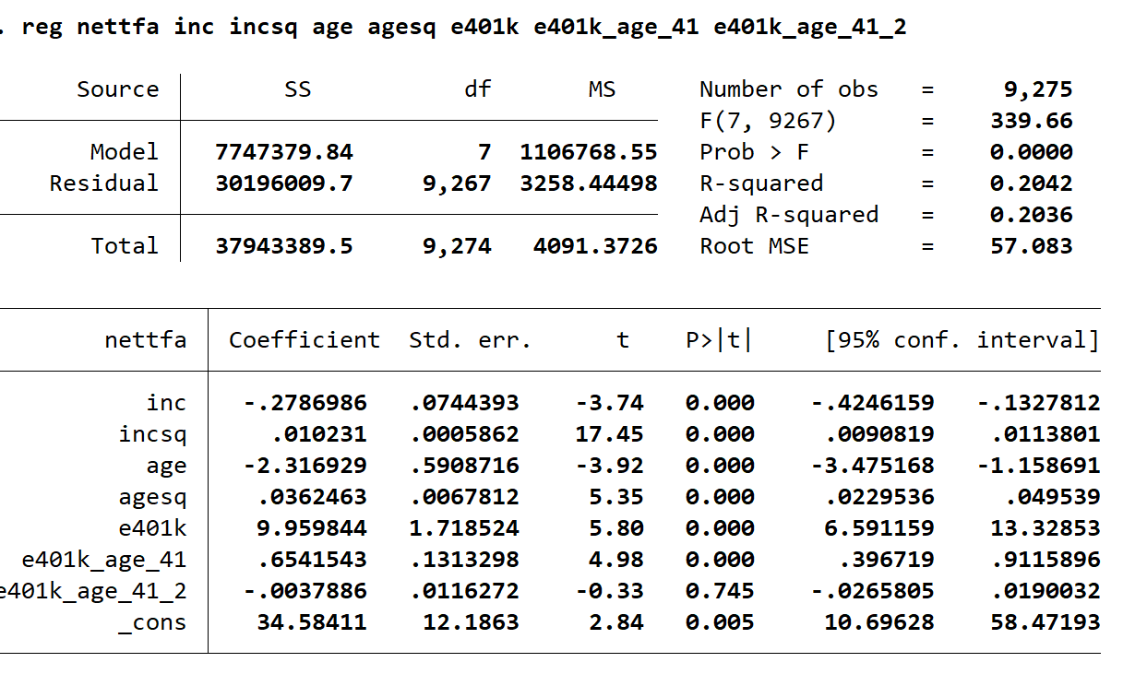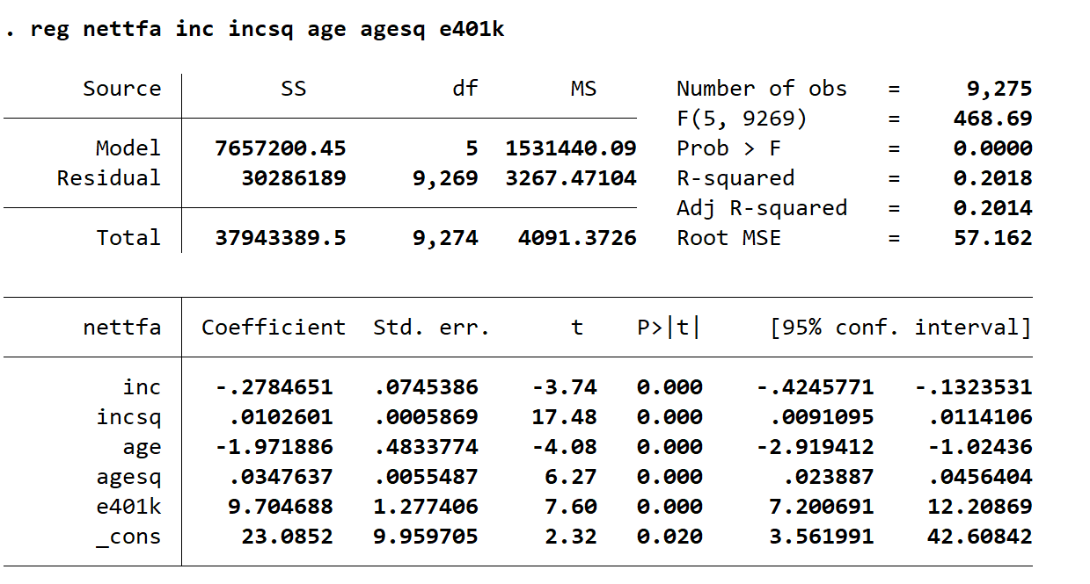
两者相差255美元，但随年龄变化，差异会更显著。
(vi)
gen fsize2 = fsize == 2
gen fsize3 = fsize == 3
gen fsize4 = fsize == 4
gen fsize5 = fsize >= 5
reg nettfa inc incsq age agesq e401k fsize2 fsize3 fsize4 fsize5
nettfa=16.34+9.455×e401k−0.240×inc+0.0100×incsq+1.495×age+0.0290×agesq+0.859×fsize2+4.665×fsize3+6.314×fsize4+7.361×fsize5 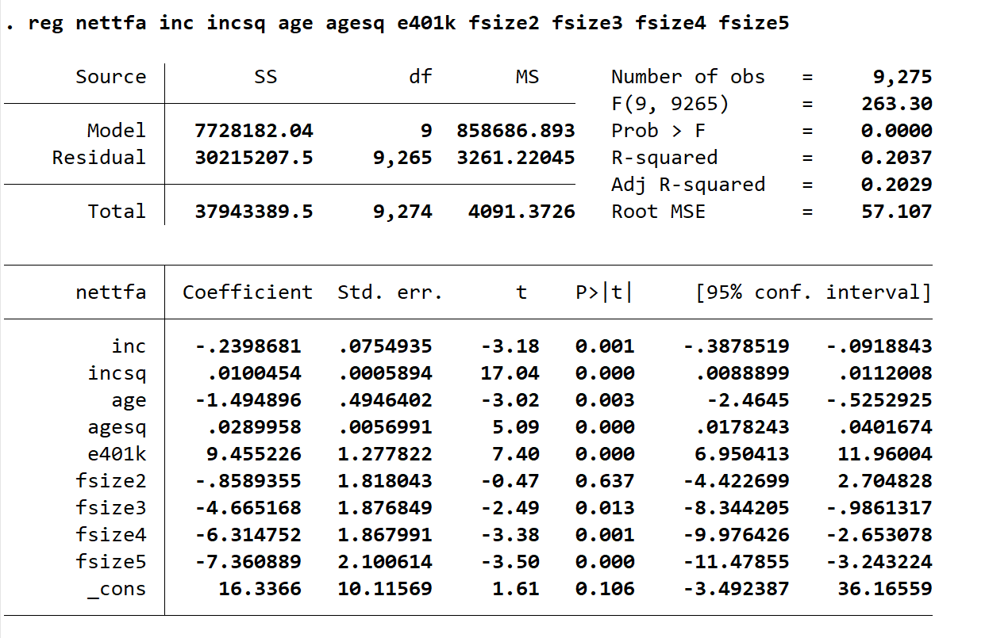
家庭规模虚拟变量在1%水平上显著，表明家庭规模对净总金融资产有显著影响
(vii)
reg nettfa inc incsq age agesq e401k if fsize == 1
scalar SSRf1 = e(rss)
reg nettfa inc incsq age agesq e401k if fsize == 2
scalar SSRf2 = e(rss)
reg nettfa inc incsq age agesq e401k if fsize == 3
scalar SSRf3 = e(rss)
reg nettfa inc incsq age agesq e401k if fsize == 4
scalar SSRf4 = e(rss)
reg nettfa inc incsq age agesq e401k if fsize >= 5
scalar SSRf5 = e(rss)
scalar SSRur = SSRf1 + SSRf2 + SSRf3 + SSRf4 + SSRf5
scalar SSRr = 30215207.5
scalar F = ((SSRr - SSRur) / SSRur) * (9245 / 20)
display F
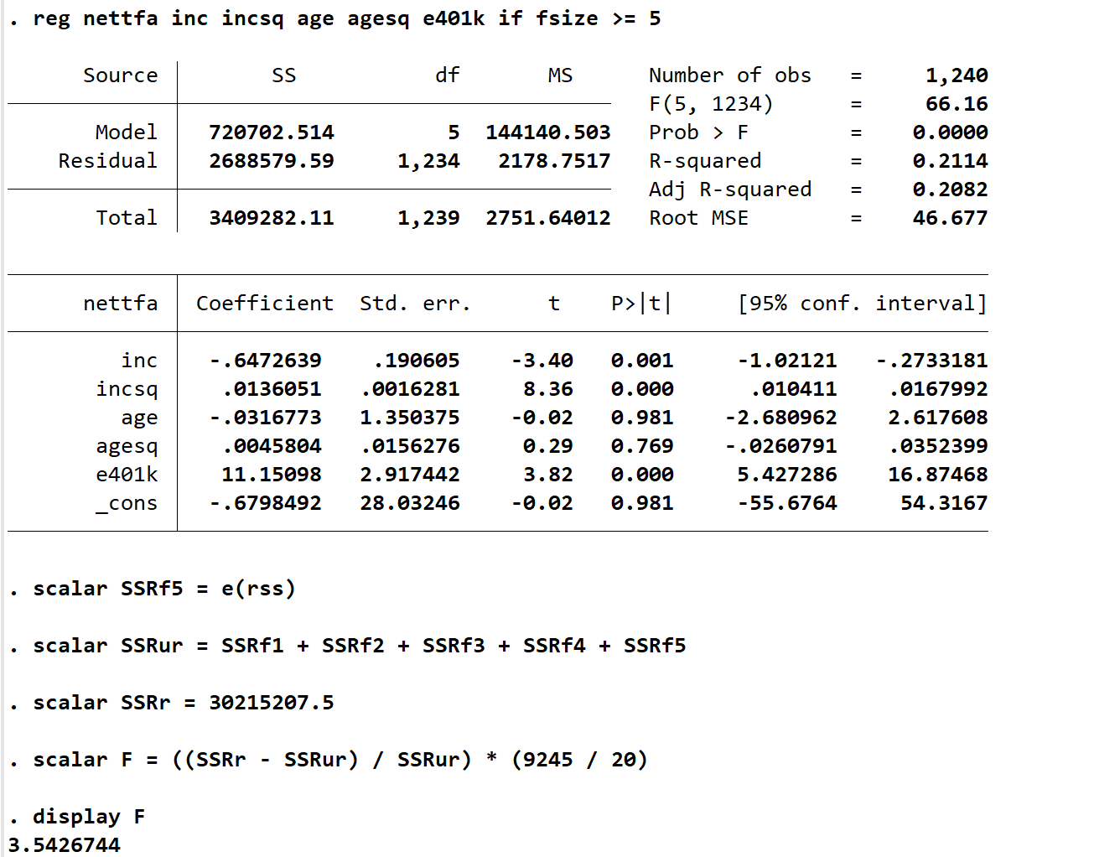

Chow统计量：3.54,p值：几乎为零,有强烈证据表明，不同家庭规模的斜率存在显著差异，仅允许截距变化是不够的。

